Project 5

Timer Control
Make a new directory called Project5 to be used to save the next form and project called timer.frm and timer.vbp respectively.
Copy the picture created in Project 4 to the clipboard with Ctrl C. Then paste the picture to a new form using Ctrl V and add additional controls so that it looks like the diagram below.
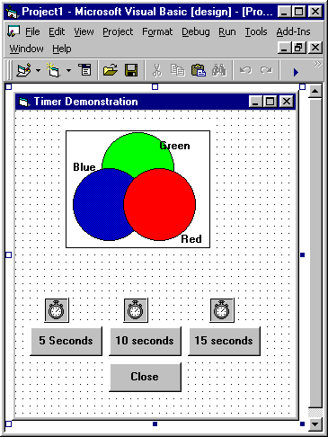
The timer control is used to activate an event after a pre-set time has elapsed. See the property window for the timer. Try to re-size the timer control to see what happens. Run your application before coding any controls. What happens to the timer controls?

Set the visible property for the frame containing the picture to false. Notice that at development time the picture is still visible, however at run time it will be invisible. The picture will become visible when a command button is pressed.

Before coding the sub procedures examine the code on the next page and try to determine what will happen at run time. Once you are happy with what you think will happen code the sub procedures.
Run the program and check how it is very useful to add brief plain English statements, that explain what a line or section of code actually does. This is particularly useful for future maintenance of the application. Comments can be added to your code if they are preceded by an apostrophe (‘) when the program is run statements preceded by an apostrophe are ignored. For example
FramePicture.Visible = True ‘Sets the frame Visible
Text after the apostrophe is ignored. Add brief comments to your code to explain what the program does.

Produce a printout of your form, form text and code.

Modify your application so that when a command button is pressed the picture appears above the pressed button. Add more comments as required. Produce a printout of the new code. There is a solution to the picture alignment problem once you have had a try to solve it look at the solution.

Extract of code to solve Timer problem
Option Explicit
Private Sub Command10_Click()
FramePicture.Visible = True
Timer10.Enabled = True
End Sub
Private Sub Command15_Click()
FramePicture.Visible = True
Timer15.Enabled = True
End Sub
Private Sub Command5_Click()
FramePicture.Visible = True
Timer5.Enabled = True
End Sub
Private Sub CommandClose_Click()
End
End Sub
Private Sub Timer10_Timer()
Timer10.Enabled = False
FramePicture.Visible = False
End Sub
Private Sub Timer15_Timer()
Timer15.Enabled = False
FramePicture.Visible = False
End Sub
Private Sub Timer5_Timer()
Timer5.Enabled = False
FramePicture.Visible = False
End Sub

